VoxSync AI: Intelligent Multilingual Video Dubbing and Subtitle Generation System

Project Description:
VoxSync AI is a video localization platform designed to help users convert video content into other languages while preserving the original meaning, segment timing, and subtitle alignment. Users can import a supported public YouTube video or upload a video from their local system. The application extracts audio, generates a transcript, allows transcript editing, translates the content into a selected target language, and generates a dubbed voiceover with synchronized subtitles.
The main objective is to reduce the manual effort involved in preparing multilingual versions of video content. Instead of handling transcription, translation, voice generation, and subtitles as separate tasks, users can review these stages in one connected workflow. The system is intended to support educational material, demonstrations, tutorials, and other content for which a translated voice track can improve accessibility.
The language selector includes English, Telugu, Hindi, Tamil, Kannada, Malayalam, Spanish, French, and German. The workflow is designed around source transcription, translation, voice generation, subtitle preparation, side-by-side comparison, and final media export. The actual language quality and voice availability depend on the configured speech-recognition, translation, and text-to-speech providers.
A key design consideration is that language support is not determined by the interface alone. A language option is useful only when the configured transcription, translation, and voice-generation services can process it reliably. For this reason, the application should keep language capability information in a central configuration and display errors or limitations when a provider cannot complete a requested operation.

Scenarios
Scenario 1: A student uploads an educational video from the local system and selects Telugu as the target language. VoxSync AI extracts the audio, transcribes the spoken content into timestamped segments, translates the transcript, generates Telugu speech, and prepares subtitles for review before export.

Scenario 2: A content creator imports a supported public YouTube video and selects Hindi. The system obtains accessible media, processes the audio, displays the transcript for correction, translates each segment, and generates a Hindi voiceover. If YouTube access is restricted, the application explains the limitation and allows an authorized local copy to be uploaded.

Scenario 3: A user notices that a technical term is incorrectly recognized. The user edits the original transcript, corrects the translation, and regenerates audio for the affected segment rather than processing the entire video again.

Scenario 4: A user generates a complete dubbed video with subtitles. The application assembles the generated speech, replaces the original dialogue in full-replacement mode, checks the final media streams, and provides the exported video and subtitle assets.

Technical Architecture:
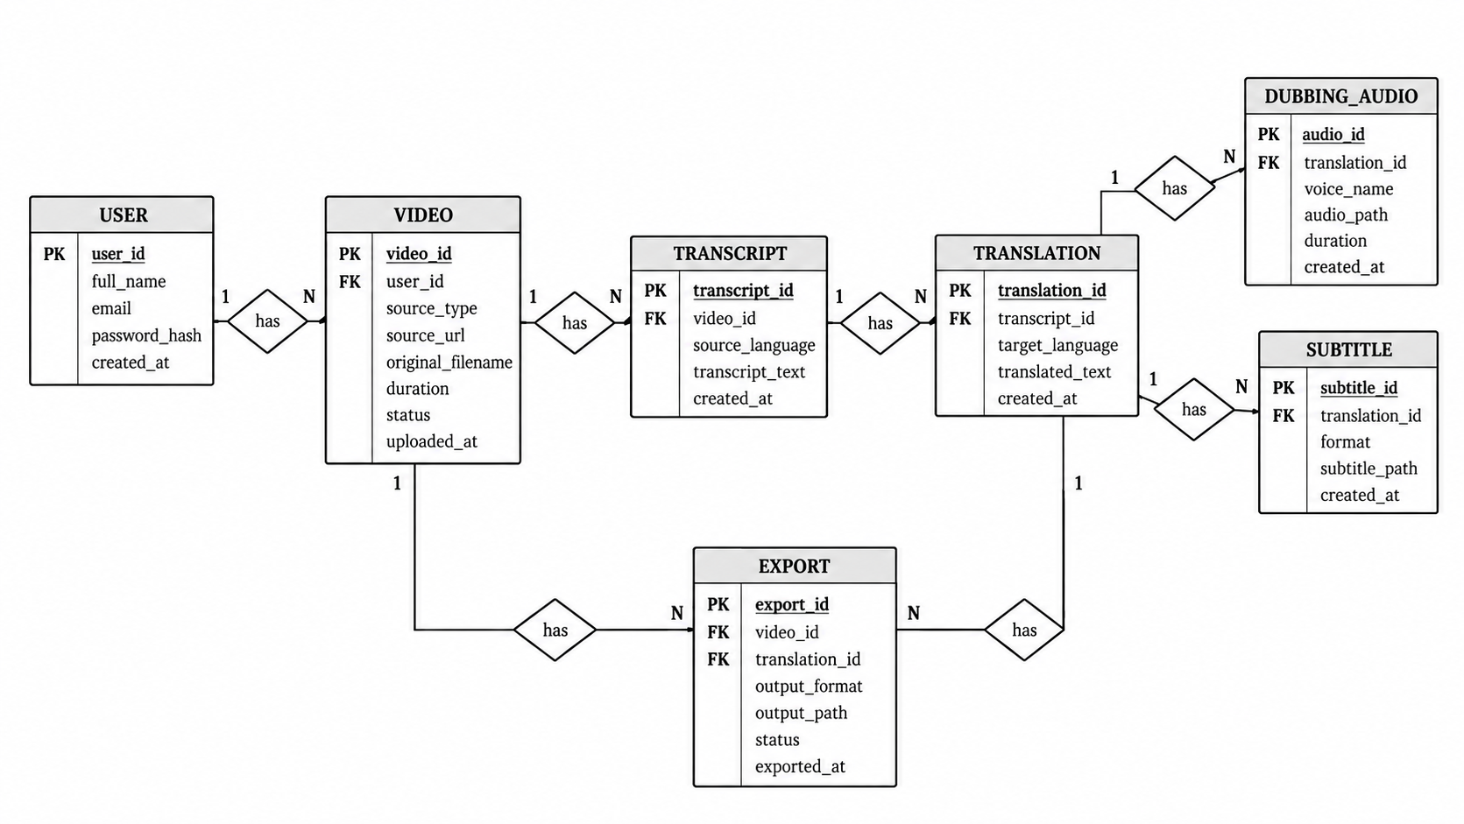

Pre-requisites:
- Python and backend framework knowledge: Python documentation
- Frontend development: React Documentation
- Media processing: FFmpeg and FFprobe documentation
- Speech recognition: Open AI Speech – to – text Documentation
- Translation and text-to-speech: Google Cloud Translation Documentation
- Environment configuration: Environment Variables Documentation
- Version Control with Git: Git Documentation

Project Workflow:

Activity 1: Model Selection and Architecture
- Activity 1.1: Identify and configure the speech-recognition, translation, and text-to-speech services used by the project.
- Activity 1.2: Define the language configuration for English, Telugu, Hindi, Tamil, Kannada, Malayalam, Spanish, French, and German.
- Activity 1.3: Design the frontend-to-backend workflow for video import, transcript editing, voice generation, subtitles, and export.
- Activity 1.4: Set up the development environment, media tools, dependencies, and secure environment variables.

Activity 2: Core Functionalities Development
- Activity 2.1: Implement local video upload and supported YouTube video import.
- Activity 2.2: Extract and validate audio, including checks for audio streams, duration, and readable media files.
- Activity 2.3: Generate timestamped transcript segments and provide transcript editing.
- Activity 2.4: Translate transcript segments into the selected target language.

Activity 3: Backend Development
- Activity 3.1: Set up the FastAPI backend and develop API routes to handle frontend requests and video processing.
- Activity 3.2: Implement audio extraction, speech recognition, and translation into the selected target language.
- Activity 3.3: Integrate text-to-speech services to generate target-language voiceovers and create subtitle files with timestamps.
- Activity 3.4: Synchronize the generated voiceover with the video, export the final media in supported formats, and validate outputs with appropriate error handling.

Activity 4: Frontend Development
- Activity 4.1: Build a responsive interface with source selection, language controls, transcript segments, timestamps, and translation fields.
- Activity 4.2: Provide segment-level edit, save, retranslate, retry-audio, and delete controls.
- Activity 4.3: Display clear processing states for transcription, translation, voice generation, subtitle generation, and export.
- Activity 4.4: Provide original and dubbed playback and ensure the final preview loads the generated output rather than a stale source URL.

Activity 5: Deployment and Verification
- Activity 5.1: Configure dependencies, environment variables, upload storage, and FFmpeg availability.
- Activity 5.2: Run local end-to-end tests for local uploads and supported YouTube imports.
- Activity 5.3: Verify the final MP4 audio stream, subtitle assets, file paths, and error handling before declaring export successful.

Activity 6: Conclusion

Milestone 1: Model Selection and Architecture
This milestone defines the architecture and service responsibilities for VoxSync AI. The project must distinguish speech recognition, translation, and speech synthesis because each stage solves a different problem and may have different provider requirements.

Activity 1.1: Identify the AI Services
Document the responsibility and input/output of each service, along with authentication needs, limits, and failure behavior. This makes it easier to replace or troubleshoot one provider without redesigning the complete workflow.
- Speech Recognition (ASR): converts the video's actual spoken audio into text and timestamps.
- Translation: converts the source transcript into the selected target language while preserving meaning and segment identity.
- Text-to-Speech (TTS): converts translated text into playable target-language audio using a compatible voice.
- Media Processing: FFmpeg and FFprobe extract audio, inspect streams, assemble speech, and validate exports.
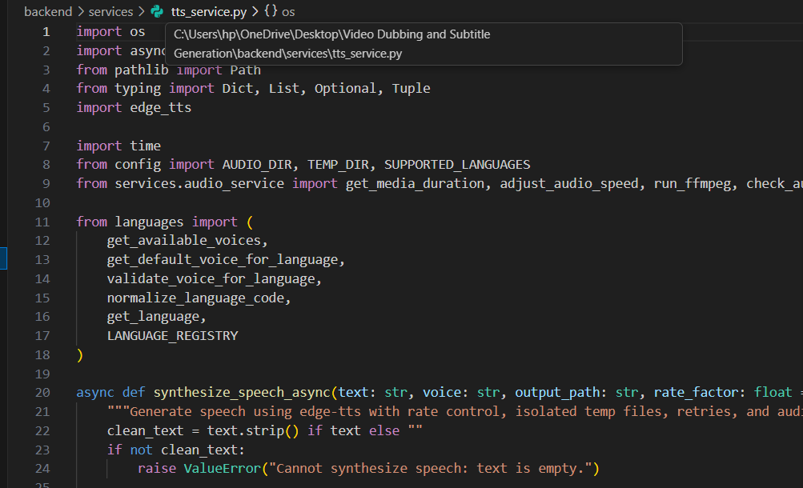

Activity 1.2: Define Language Configuration
Use the same central language configuration throughout the interface and backend so that displayed language names, provider codes, and available voices remain consistent. Test representative language pairs instead of relying only on dropdown options.
Maintain one central configuration for the nine visible language options. For each language, record the display label, provider-specific language code, supported voice identifiers, and verification status. Do not assume that the same locale code is accepted by every service.
The configuration should also distinguish between a language being available in the dropdown and a language having passed end-to-end verification. Store a small test result for each supported language combination, including the input language, target language, voice identifier, and date of verification. This avoids claiming universal language support based only on a successful request for one language.
- English
- Telugu
- Hindi
- Tamil
- Kannada
- Malayalam
- Spanish
- French
- German
A language should be marked as verified only after a real end-to-end test confirms that translated text is spoken in the intended language. If a provider does not support a language, show a clear limitation instead of silently using an unrelated voice.
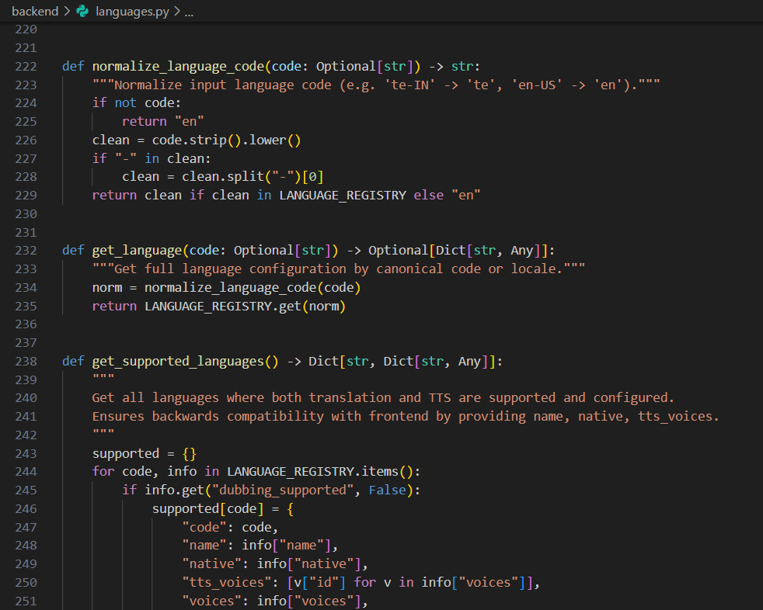

Activity 1.3: Define the Application Architecture
Keep the frontend responsible for user interaction and the backend responsible for validation, orchestration, and file processing. Return predictable responses so that the interface can update the correct project and segment.
- Frontend: accepts a local video or supported YouTube URL, exposes language selection, and displays transcript and playback controls.
- Backend orchestration: validates inputs, manages job status, calls processing services, stores outputs, and returns structured responses.
- Media processing: extracts audio and validates media duration and streams.
- AI services: transcribe source speech, translate text, and synthesize target-language speech.
- Export service: places dubbed audio on the video timeline, generates or packages subtitles, and validates the final media file.

Activity 1.4: Development Environment Setup
A clean setup should be tested from a fresh terminal and documented in the project instructions. Confirm that environment variables are loaded by the backend process and that media tools are accessible from the same environment.
Install the dependencies required by the existing repository. Do not replace the current framework or install unrelated libraries without checking the project configuration.
Before adding a new dependency, review the existing project files and verify the installed versions. Keep frontend and backend dependency lists reproducible, document any operating-system requirements, and test the application after upgrades. This helps avoid version conflicts and makes the setup easier to repeat on another computer.
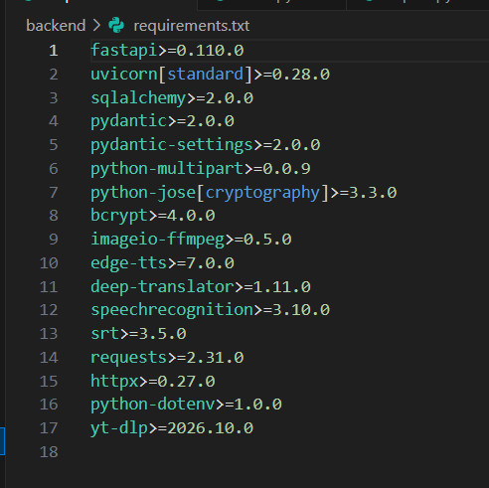

Milestone 2: Core Functionalities Development
This milestone implements the media-to-transcript workflow and prepares the data used by later translation and dubbing stages.

Activity 2.1: Video Import
After import, show the user which file or source is being processed and confirm that the media is genuinely available. Keep separate project-specific files so simultaneous uploads do not overwrite each other.
- Local upload: validate the file type, file size, media duration, and upload result. Store each file under a unique project-specific path.
- YouTube import: validate the URL and confirm that the selected import method can access the actual media. A title or metadata response is not a video file.
- File safety: use safe generated filenames, handle temporary files carefully, and avoid overwriting files used by active processing jobs.

Activity 2.2: Audio Extraction and Validation
Validation should happen before expensive AI requests are made. Clear checks at this stage reduce confusing downstream errors and help users understand whether the problem is the source file or a later service.
Use FFmpeg to extract the source audio and FFprobe to inspect the input video. Confirm that the media contains a usable audio stream, that the extracted file is readable, and that the audio duration is consistent with the video. If the file contains no audio or the extraction fails, stop processing and show an actionable error.
Audio extraction should preserve enough quality for speech recognition while avoiding unnecessarily large intermediate files. The backend should check the process exit code, confirm that the output file exists, and inspect its duration before continuing. Temporary audio should be removed when it is no longer required, while files needed for retry or final assembly should remain available for the active job.
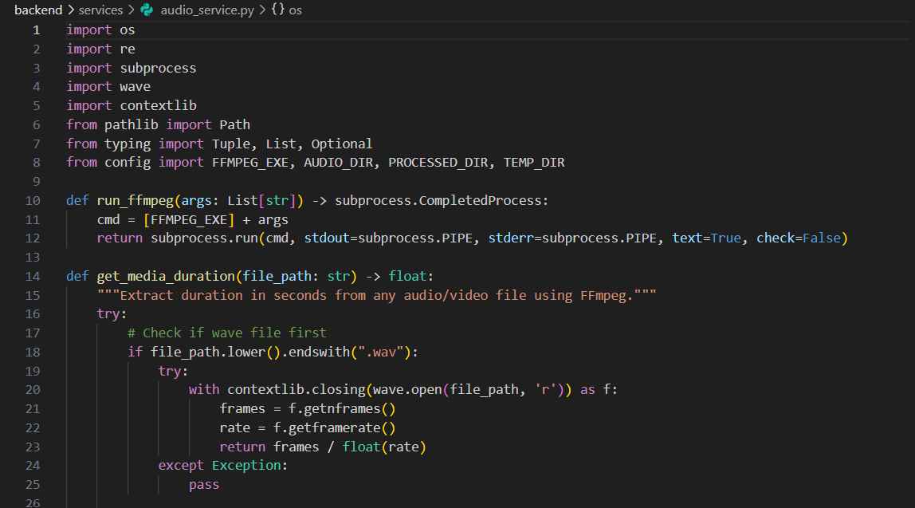

Activity 2.3: Speech Recognition and Transcript Segments
Preserve the timing and order of every segment so the transcript can be edited, translated, and aligned with generated speech. Record failures at segment or job level rather than silently substituting sample text.
Pass the extracted audio to the configured ASR service. Store each recognized segment with a stable identifier, source text, start time, end time, and recognition status. Long videos may be processed in chunks, but chunk boundaries must not create repeated or missing words.
Recognition quality can be affected by background noise, multiple speakers, music, accents, and low recording volume. The application should therefore make the transcript editable and avoid treating machine-generated text as guaranteed to be correct. For long recordings, chunking should include a controlled overlap or boundary strategy so that words are not lost or duplicated between chunks.
- Do not use demonstration sentences or fabricated fallback transcripts.
- Do not report a full video as transcribed if only a small section was processed.
- Provide a retry option when recognition fails and preserve user-edited text when appropriate.
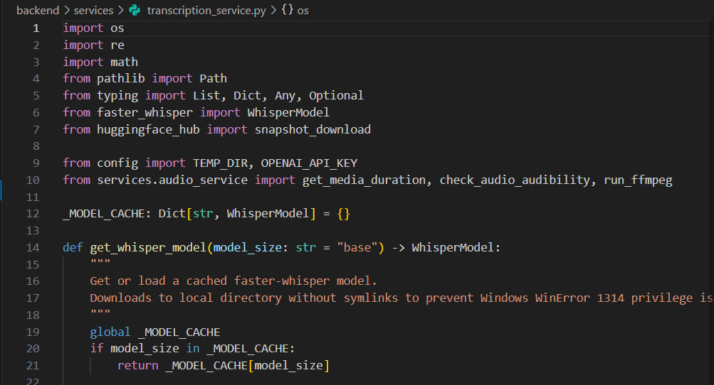

Activity 2.4: Transcript Editing
The editing interface should make it clear which text is original and which has been changed by the user. Save changes reliably and use the latest approved source text when translation is requested.
Allow users to review and correct the recognized source text before translation. Save edits against the correct project and segment ID. Timestamp edits must be validated so that segment end times do not precede start times or exceed the media duration.

Milestone 3: Backend and Voiceover Development
This milestone focuses on backend orchestration and generation of genuine translated speech. Each stage must report its own status; a successful API response alone is not proof that audible dubbing has been produced.

Activity 3.1: Backend Service Responsibilities
Use consistent response structures and meaningful HTTP error codes across endpoints. This allows the frontend to distinguish validation problems, provider failures, and processing errors and present an appropriate next step.
- Validate request data and accept only the fields required by each endpoint.
- Associate every job, transcript segment, translation, and audio file with the correct project.
- Return structured JSON responses containing success status, relevant IDs, output paths or URLs, and clear error messages.
- Record diagnostic information without logging API secrets or sensitive user content unnecessarily.
- Await asynchronous processing jobs and avoid marking a stage complete before its output has been validated.

Activity 3.2: Text-to-Speech Generation
Track generation results separately for each segment and confirm that each returned audio file is usable. If a voice or language is unsupported, report the limitation rather than returning unrelated or empty audio.
For each segment, send the translated text to a TTS voice that supports the selected target language. Save generated audio to a unique file, then verify that the file is readable and contains an audio stream. Keep the provider name, voice identifier, target language, segment ID, generation status, and duration available for debugging.
Generated speech should be checked for more than file existence. A valid output should contain an audio stream, have a non-zero duration, and be associated with the expected segment and target language. If the service returns a URL, the backend should verify that the file can be retrieved before recording the segment as complete.
- Reject empty or placeholder translations.
- Do not silently use the original audio when TTS generation fails.
- Retry transient failures a limited number of times and expose failed segment IDs.
- Provide a Retry Audio control that regenerates the selected segment from its current translated text.

Activity 3.3: Segment Audio Assembly
Assembly should account for gaps, overlaps, and differences in segment duration. Listen to the combined result and verify that all expected segments are present before attaching it to the video.
Assemble generated segments in timeline order. Convert files to compatible formats and sample rates when required. Place each segment at its intended timestamp, preserve pauses, and detect missing or overlapping segments. If generated speech is longer than the available interval, report the timing conflict or apply a controlled speech-rate adjustment; do not cut off words silently.
The assembly process should consider pauses between sentences, segment offsets, and differences in the duration of translated speech. Some translations may take longer to speak than the source segment. The application should preserve intelligibility and report any timing changes rather than silently dropping content or overlapping adjacent segments.

Activity 3.4: Subtitle Generation
Keep subtitle generation aligned with the selected output language and clearly identify whether captions are embedded in the video or delivered as a separate file. Test the exported file in a standard media player or subtitle viewer.
Generate subtitle cues from the transcript or translated segments, preserving valid start and end times. Support an export format such as SRT or VTT when implemented. Validate cue ordering and ensure that subtitle text corresponds to the selected source or target language.
Subtitles should remain readable on screen and should not appear for negative durations or outside the length of the media. When translated speech is used, the target-language subtitle cues should ideally follow the generated voice timing. The application should also make clear whether the exported subtitle file contains the original transcript or the translated text.
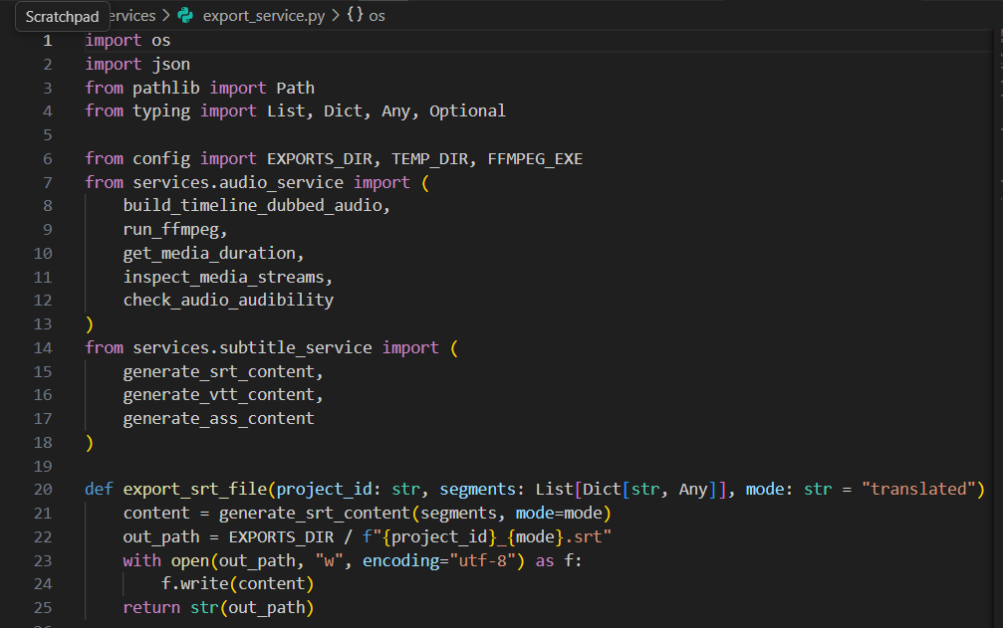

Milestone 4: Frontend Development
This milestone focuses on the user experience for importing videos, reviewing transcripts, selecting languages, generating voiceovers, creating subtitles, and exporting the final media.
The interface should make the current stage and next available action obvious to first-time users. Use consistent labels, helpful empty states, and concise messages for long-running work. The user should not need to understand the underlying AI services or media commands to complete the normal workflow.

Activity 4.1: Designing the User Interface
Use consistent labels and a logical order for each step, with enough space to review longer transcript segments. Make the primary action at each stage obvious and ensure that controls remain usable on different screen sizes.
- Create a clear source-selection area with two options: Upload from Local System and Import from YouTube.
- Display the selected source video and its verified duration.
- Provide source-language detection or manual selection and a target-language selector.
- Use responsive transcript cards that show segment number, timestamps, source text, and translated text.
- Provide clear controls for saving edits, retranslating, retrying audio, adding a segment, and removing a segment.
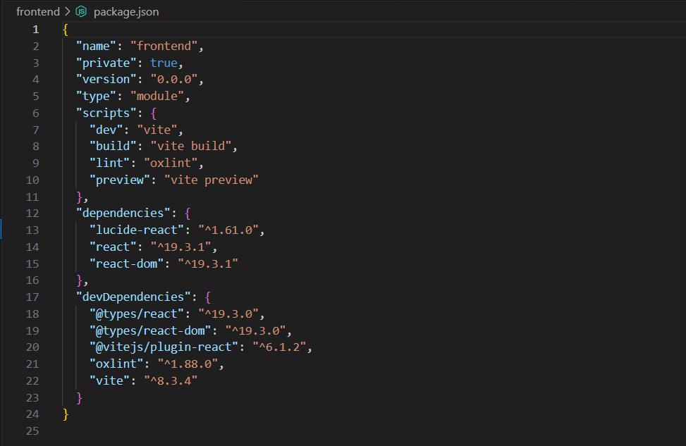

Activity 4.2: Asynchronous Processing States
The interface should remain responsive while long-running work continues. A failed request should restore the relevant controls and explain whether the user can retry, change an input, or start the process again.
Show independent status indicators for importing, audio extraction, transcription, translation, voice generation, subtitle generation, audio assembly, and export. Disable only the actions that cannot safely run in the current state. Restore controls after both successful and failed requests.
Status messages should distinguish between queued, processing, completed, and failed states. If a job takes longer than expected, the interface should continue to show that it is working or provide a retry option. Avoid leaving a permanent spinner after a request fails, and ensure that repeated clicks do not accidentally create duplicate processing jobs.
- Display progress or a meaningful waiting state during long-running tasks.
- Show actionable errors instead of placeholder output.
- Do not mark a job complete just because a request returned HTTP 200.

Activity 4.3: Original and Dubbed Playback
Clearly label the original and generated versions so users can judge the result accurately. Reload the preview when a new export is created and show a useful empty state when no valid dubbed output exists.
The original player should use the original media. The dubbed preview should use the newly generated dubbed audio or exported video. Refresh the media URL after regeneration and avoid stale frontend state. If dubbed media is unavailable, show a clear message instead of silently playing the original source.
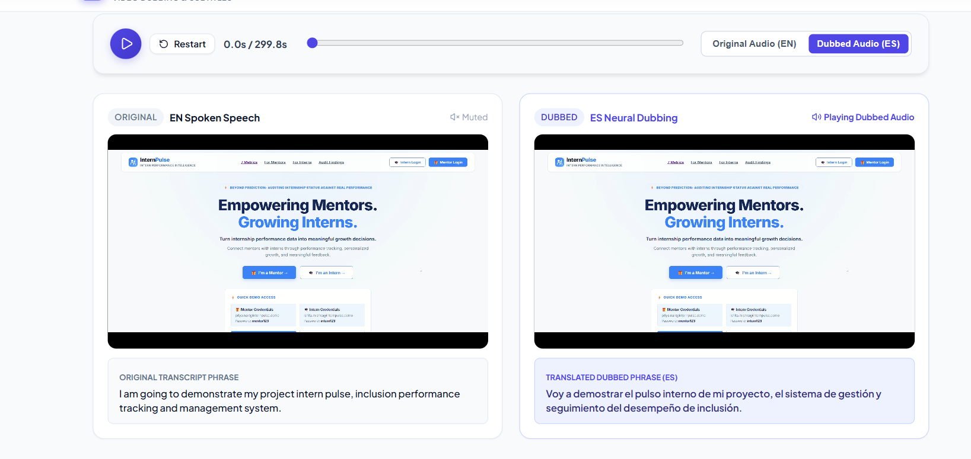

Activity 4.4: Compare and Export
Before enabling download, confirm that the export has completed and that the displayed filename refers to the newest output. Keep subtitle download information alongside the video when both assets are available.
- Allow users to compare the original and dubbed output.
- Show whether subtitles are embedded or provided as a separate file.
- Provide clear export status, output filename, and download action.
- Keep the original video unchanged and create a separate exported file.

Milestone 5: Deployment
This milestone prepares VoxSync AI for local operation and deployment. The environment must include the application dependencies, media-processing binaries, provider configuration, and a writable storage location for uploads and generated media.

Activity 5.1: Preparing the Application for Local Deployment
Confirm the frontend and backend addresses, required ports, environment configuration, and media-tool paths before running the complete workflow. Write down the verified startup and shutdown steps for future testing.
Create and activate a virtual environment, then install dependencies from the repository's dependency file.
After installation, start the backend and frontend in separate terminals if the repository requires separate processes. Read the startup output for missing packages, invalid configuration, port conflicts, and provider authentication failures. Keep a short setup note with the verified commands so that another developer can reproduce the environment.
python -m venv .venv
.venv\\Scripts\\activate
pip install -r requirements.txt
Configure the environment variables required by the actual providers. Use the names expected by the codebase, and never commit credentials.
ASR_API_KEY=your_key_if_required
TRANSLATION_API_KEY=your_key_if_required
TTS_API_KEY=your_key_if_required
The variable names above are examples only. Replace them with the exact names used by the configured services.

Activity 5.2: Local Testing and Verification
Use short, known test videos first, then test longer files and less ideal audio conditions. Keep a simple test record of the selected languages, expected output, actual result, and any errors found.
- Start the backend and frontend using the commands defined in the project's README or package scripts.
- Upload a short video from the local system and confirm that the actual audio is extracted.
- Import a supported YouTube video and verify that actual media—not just metadata—is available.
- Confirm that the transcript contains genuine speech and multiple correctly timed segments where appropriate.
- Translate into Telugu, Hindi, Tamil, Kannada, Malayalam, Spanish, French, and German wherever the configured providers support them.
- Play the standalone voiceover and verify that the selected language is spoken.
- Export the MP4 and inspect the audio stream with FFprobe.
- Test failure handling for missing audio, unsupported languages, failed TTS calls, locked files, and invalid YouTube URLs.
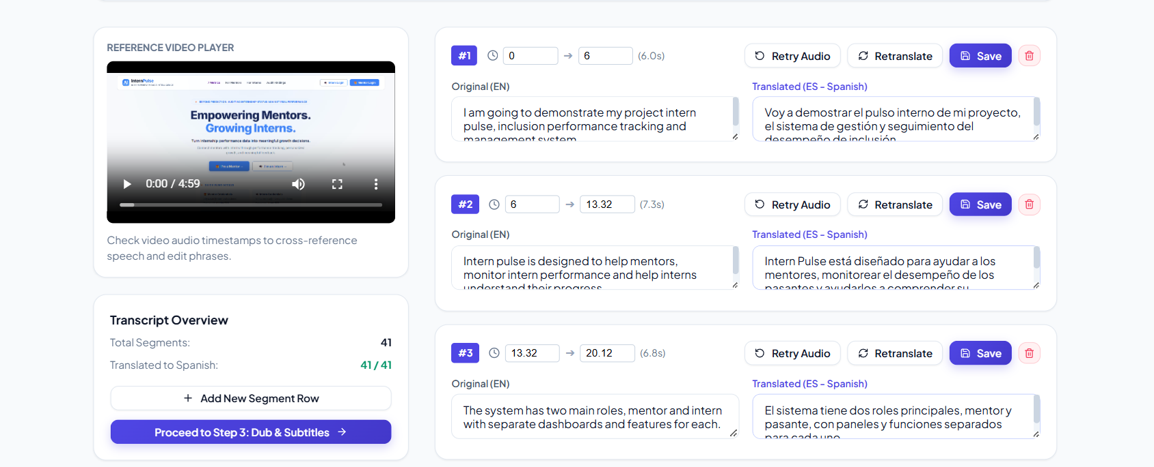

Activity 5.3: Deployment Considerations
Review storage persistence, file access permissions, resource limits, and secret management for the intended hosting environment. Re-test the full upload-to-export workflow after deployment because local filesystem and process behavior may differ.
- Ensure FFmpeg and FFprobe are installed in the deployment environment and available to the application process.
- Use persistent or job-specific storage for media files and define cleanup rules for temporary files.
- Set appropriate upload size and processing time limits.
- Protect API keys, validate uploads, and avoid exposing internal file paths to users.
- Use a deployment configuration appropriate to the hosting platform; do not assume local file paths or local services will work unchanged in production.

Exploring the Website’s Web Pages:

Video Import Page
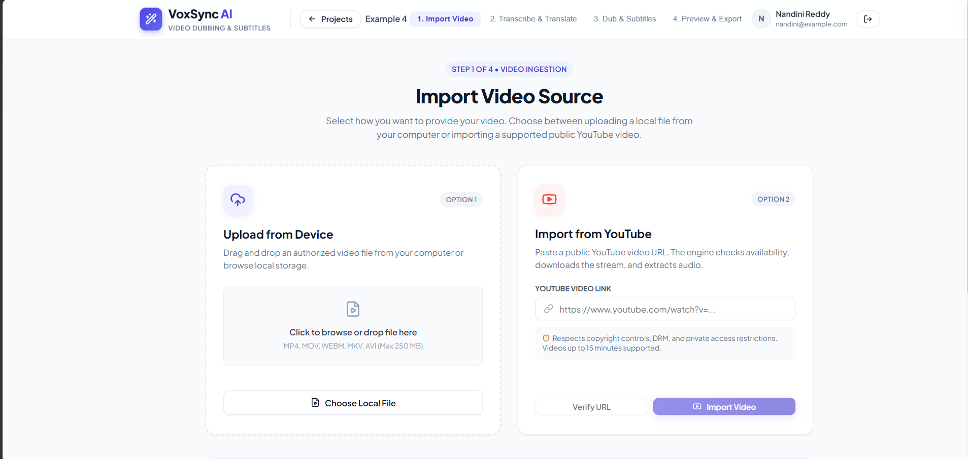
Description: This page offers two import methods: local video upload and supported public YouTube video import. It should validate the selected source, show progress, report media-access errors, and confirm when the actual video and audio are ready for processing.

Language Selection Page / Panel
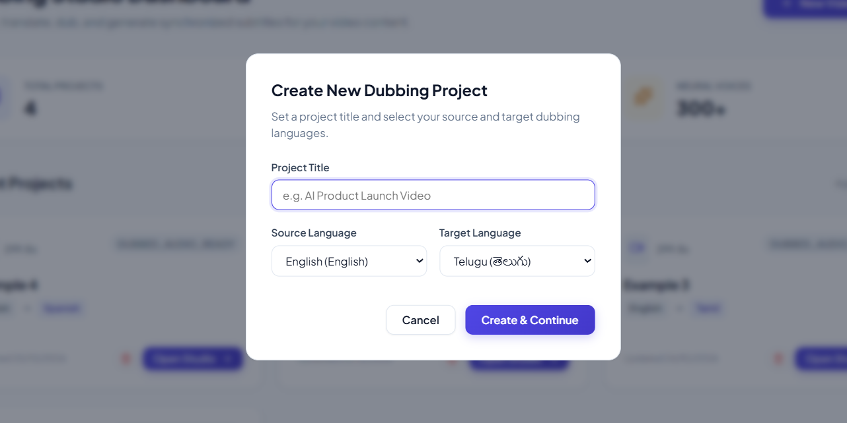
Description: Users select or confirm the spoken source language and choose a target language from English, Telugu, Hindi, Tamil, Kannada, Malayalam, Spanish, French, and German. The application should expose only the combinations supported by the configured providers and report unsupported combinations clearly.

Transcript and Translation Editor
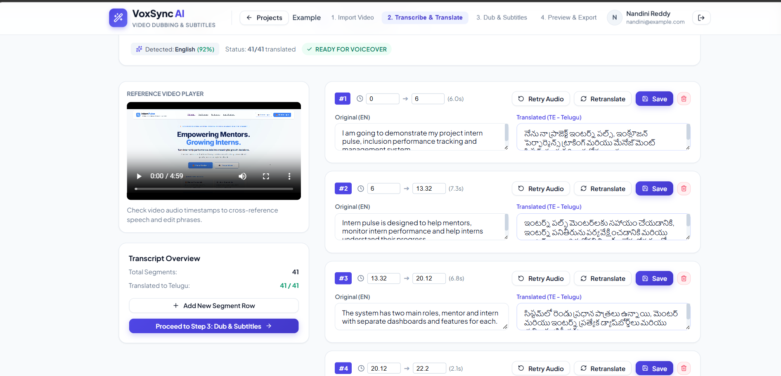
Description: This page displays timestamped source transcript segments alongside their translated text. Users can edit text, save changes, retranslate segments, add or delete rows, and retry failed operations. The segment count and translated count must reflect real stored data.

Voiceover and Subtitle Page
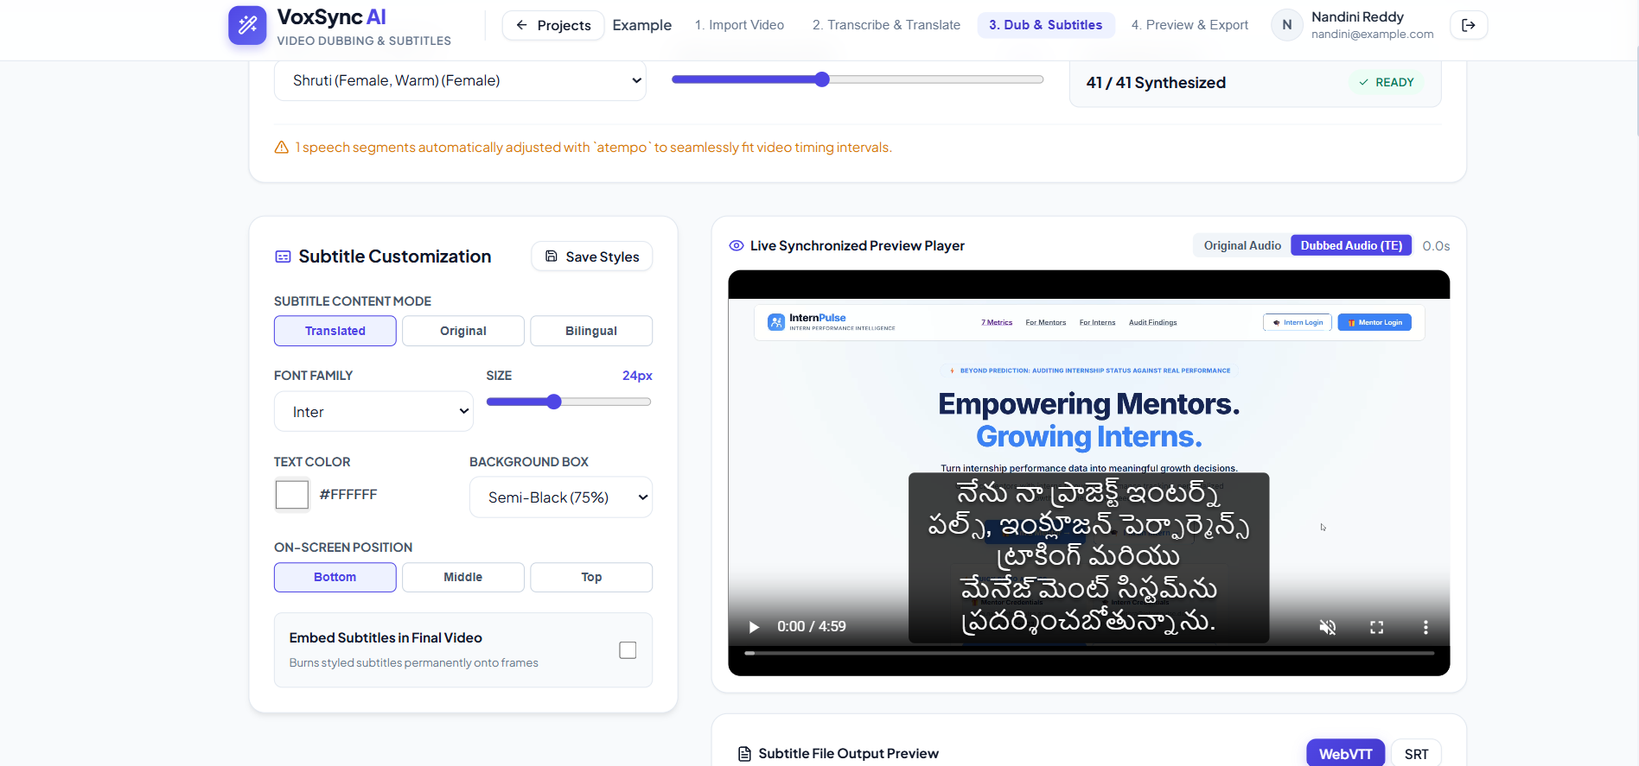
Description: This page generates target-language speech from translated segments and creates subtitle cues. It should show per-segment generation status, voice selection, timestamps, audio duration, and errors. Missing or failed audio segments must be visible and retryable.

Compare and Export Page
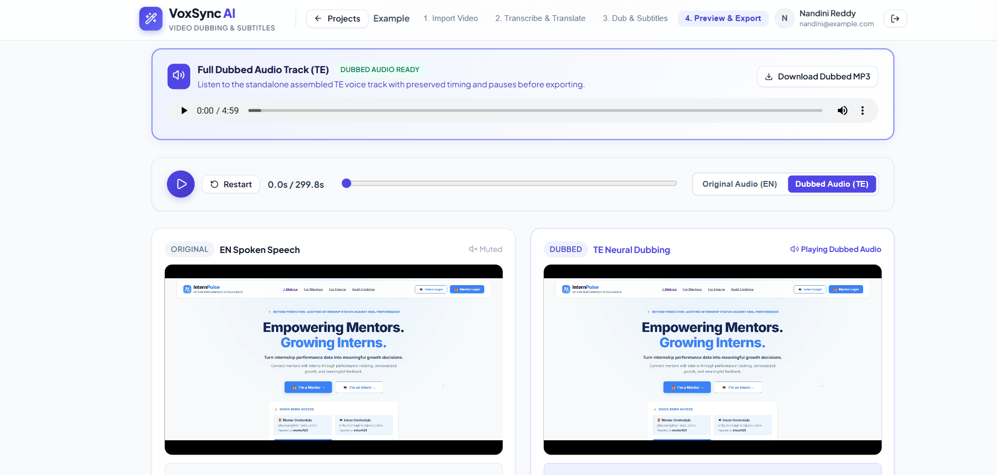
Description: This page allows users to compare the source video with the dubbed output, review subtitle settings, and export the final media package. In full-replacement mode, the final video must use the generated dubbed audio instead of the original dialogue. Export status must reflect actual validation.

Conclusion:
VoxSync AI is an intelligent multilingual video localization system designed to simplify the process of converting video content into different languages. The application integrates video import, speech recognition, transcript editing, text translation, text-to-speech generation, subtitle creation, audio synchronization, playback comparison, and media export into a unified workflow. By combining frontend interaction with backend processing and AI-based services, the system aims to make multilingual video content more accessible and convenient for users. Reliable performance depends on accurate transcription and translation, proper audio synchronization, valid subtitle timing, secure configuration, and successful end-to-end testing.
The project also provides opportunities for future enhancement, including speaker-aware voice selection, improved synchronization between translated speech and subtitles, processing progress tracking, job history, recovery from interrupted tasks, and more comprehensive output quality checks. These improvements can make the application more efficient, user-friendly, and reliable. Overall, VoxSync AI demonstrates the practical application of artificial intelligence and media-processing technologies to multilingual video dubbing and subtitle generation, with the potential to support content creators, educators, and other users who want to reach audiences across different languages.

